**TLEACH in NetSim**

**Software Recommended:** NetSim Standard v11.1 (32/64-bit), Visual Studio 2019

**Low-energy adaptive clustering hierarchy ("LEACH")**is a [MAC](https://en.wikipedia.org/wiki/Media_access_control) protocol which is integrated with clustering and a simple routing protocol in [wireless sensor networks](https://en.wikipedia.org/wiki/Wireless_sensor_network) (WSNs). The goal of LEACH is to lower the energy consumption required to create and maintain clusters in order to improve the life time of a wireless sensor network.

This Cross Layer Protocol is implemented in NetSim in MAC layer which involves ZigBee Protocol and Network layer which involves DSR protocol. The clustering of sensors happens in the Network layer and the Cluster head election involves interacting with the MAC layer to obtain the remaining power of the sensors.

TLEACH is Threshold-based LEACH in which nodes with remaining energy greater than a threshold value are considered to elect the cluster head. The sensor that is closer to the sinknode is elected as the cluster head. Whenever all sensors in a cluster reach energy levels lower than the threshold, the threshold is reduced.

A **TLEACH.c** file is added to the DSR project.

1. For this implementation of TLEACH, the number of Clusters is fixed as 4 and all the 4 clusters are equal. If the user wants to change it, then he/she must also change the static routing for the Cluster Heads and the ClusterElement array accordingly.
2. To make 4 equal clusters the number of sensors must be 4,16,36,64,100. Depending on the number of sensors, the ClusterElements array must be defined. Here, it has been defined and commented for 4,16,36,64,100 sensors. Uncomment the one you want to use.

The file contains the following funcitons:

fn_NetSim_TLEACH_CheckDestination()

This function is used to check whether the current device is the destination (i.e) the sinknode or not. Else the packet will be forwarded to the next hop.

fn_NetSim_TLEACH_GetNextHop()

This function is used to identify the next hop in cases where the current device is either a sensor within the cluster or the cluster head. Static routes are defined in this function. It returns the Device id of the next hop.

fn_NetSim_TLEACH_AssignClusterHead ()

This function is used to dynamically assign cluster heads within a cluster based on the residual energy. The sensor with higher remaining power in comparison to other sensors within the same cluster will be elected as the cluster head.

fn_NetSim_TLEACH_IdentifyCluster()

This function is used to determine the cluster to which a sensor belongs. It returns the cluster id of the cluster.

fn_NetSim_TLEACH_init() is used to initialize TLEACH parameters such as the sinknode ID and the initial Threshold value.

fn_NetSim_TLEACH_set_threshold() is used to reduce the threshold value for clusters whenever all sensor in a cluster reach energy levels less than the threshold.

# Steps:

1. After you unzip the downloaded project folder, Open NetSim Home Page click on **Open Simulation**

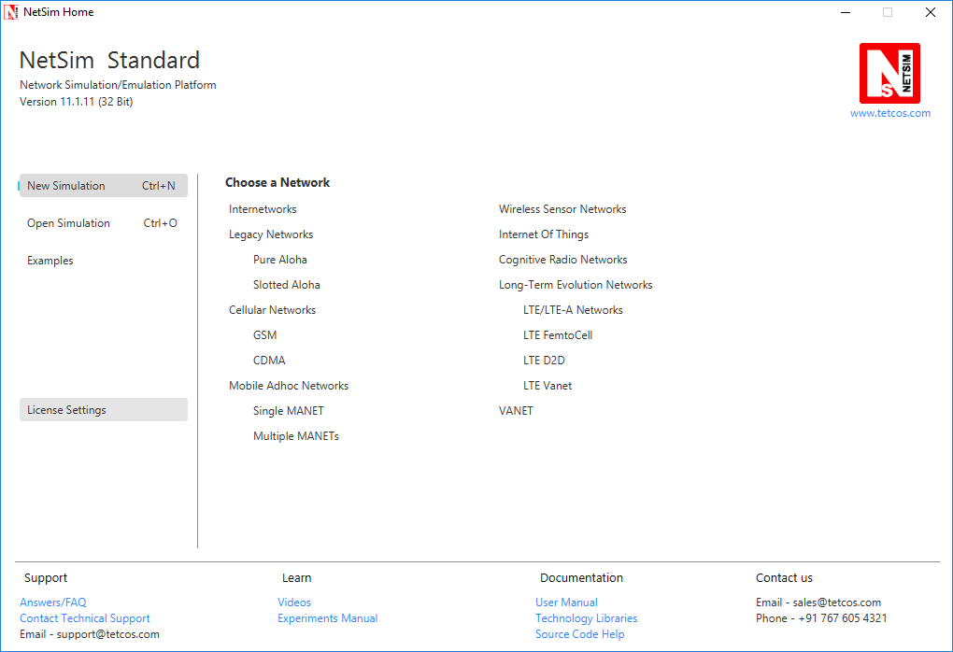

1. Click on **Workspace options**

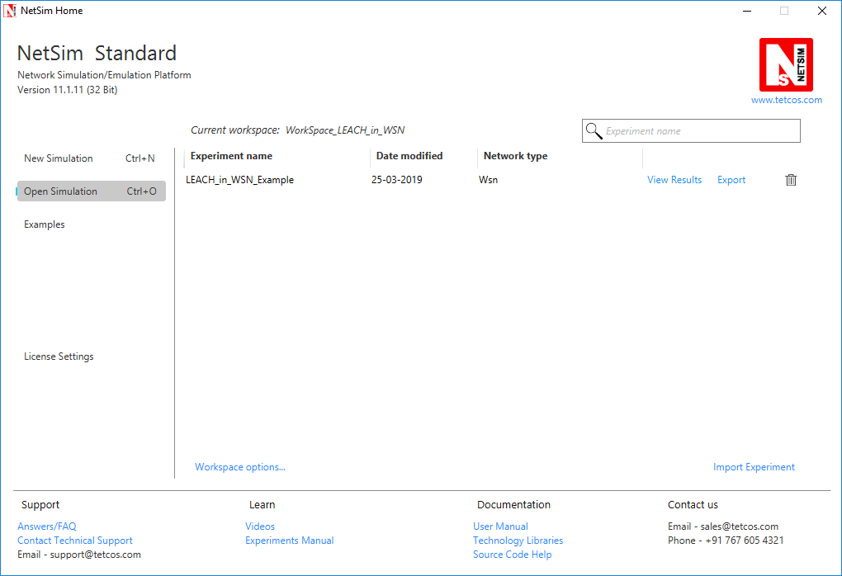

1. Click on **More Options,**

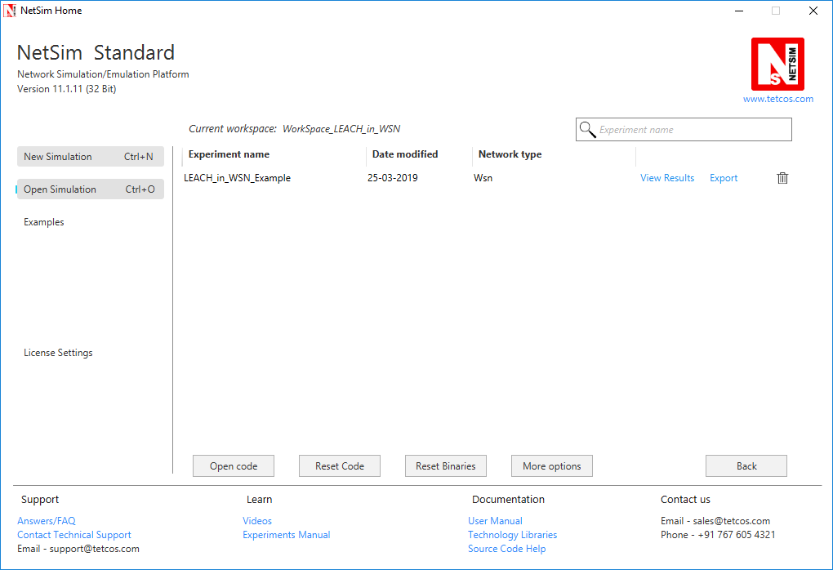

1. Click on **Import**, browse the extracted folder and go into the WorkSpace_TLEACH_in_WSN directory, click on select folder and then click on OK.

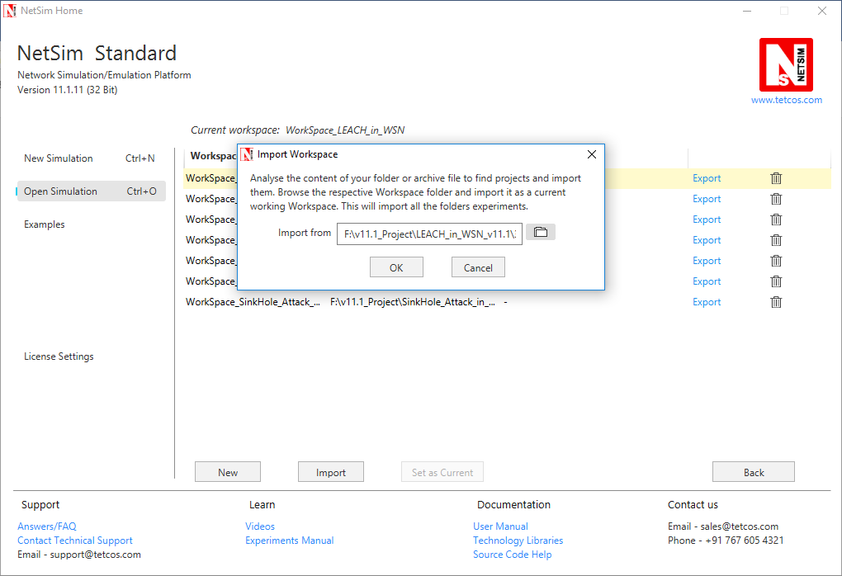

1. Go to home page, Click on **Open Simulation** 🡪 **Workspace options** 🡪 **Open code**

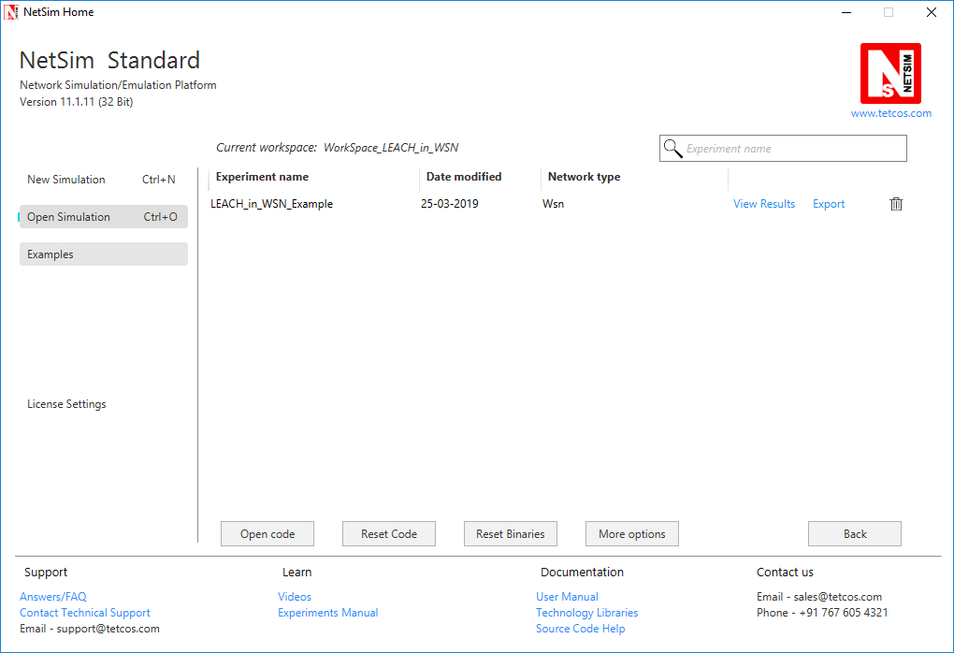

1. Right click on the DSR Project and select rebuild.

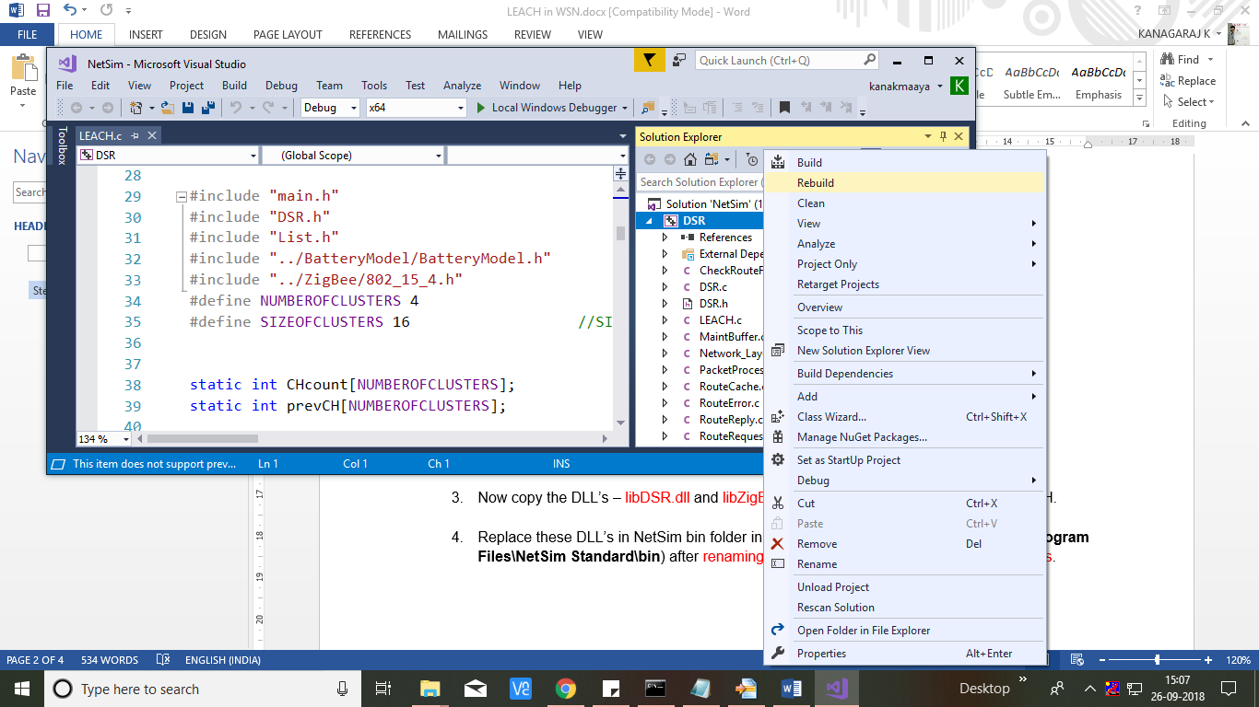

1. Upon rebuilding, **libDSR.dll** will automatically get updated in the respective bin folder of the current workspace.

**Note:**

* Based on whether you are using NetSim 32 bit or 64 bit setup you can configure Visual studio to build 32 bit or 64 bit Dll files respectively as shown below:

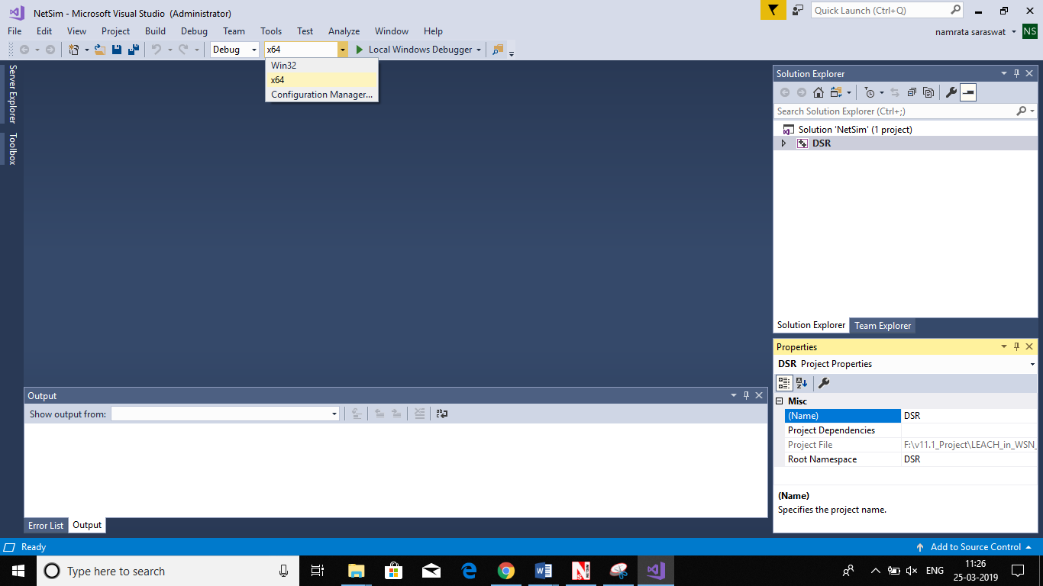

* While importing the workspace, if the following warning message indicating Software Version Mismatch is displayed, you can ignore it and proceed.

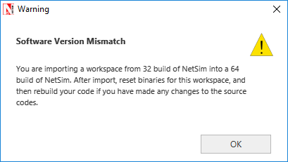

1. Go to NetSim home page, click on **Open Simulation**, Click on **TLEACH_in_WSN_Example**.

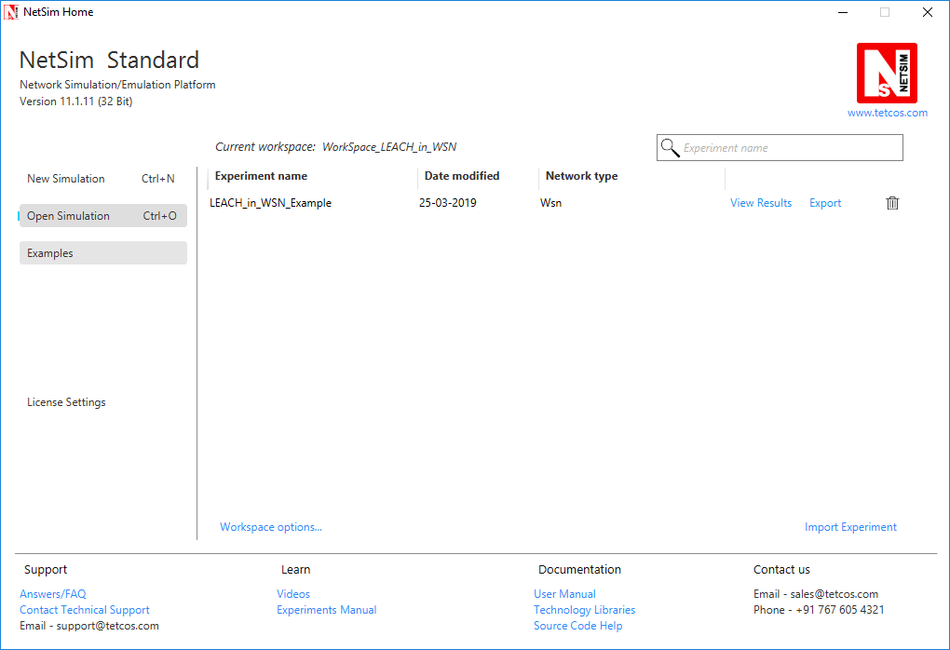

1. Now create a Network Scenario in NetSim WSN Network as per the Number of clusters and size of clusters that are set in the TLEACH code. By default the code runs for a scenario with 64 sensors uniformly placed, with the SINKNODE placed as per the screenshot below.

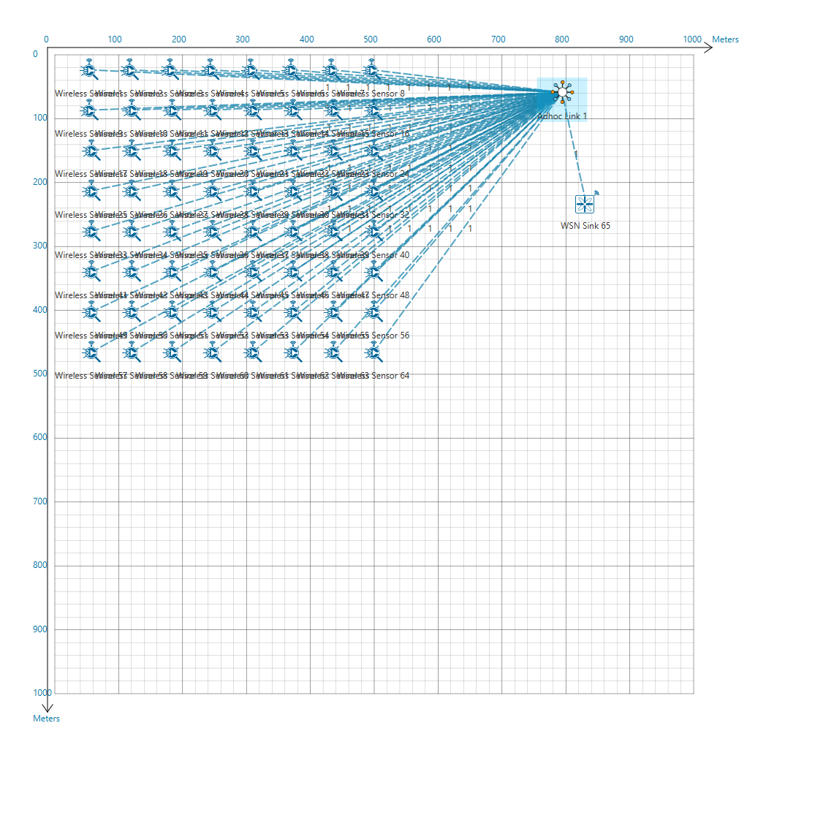

A sample Configuration.netsim file is also provided in the Config_File folder along with this project which can be opened in NetSim directly.

1. Run the simulation.
2. View the packet animation. You will note that the sensors directly start transmitting packets without route establishment since the routes are statically defined in TLEACH. You will also note that the cluster heads keep changing dynamically.